Student name : Imran Khan

Developing Mobile Web Based Applications: An Introduction H17J34

LO3 Assessment

# Introduction

# Screen shots of all pages

## Registration page

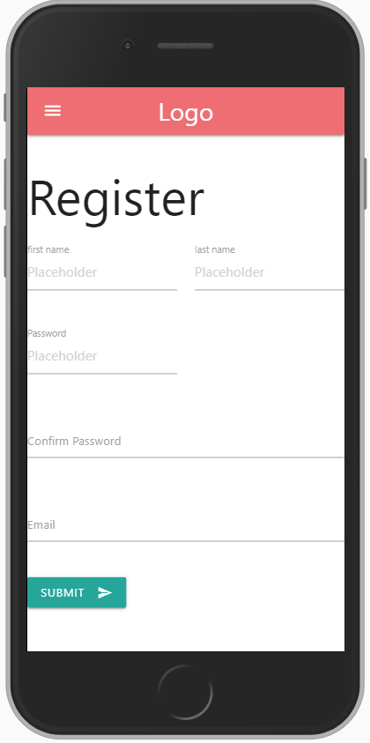

## Login page

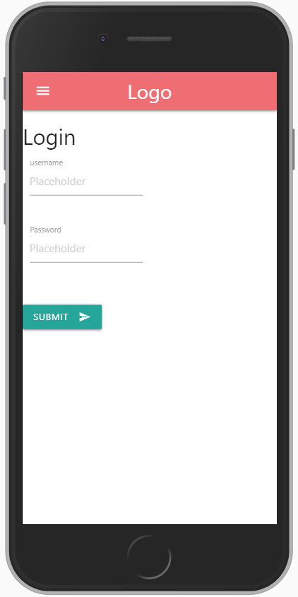

## Home page

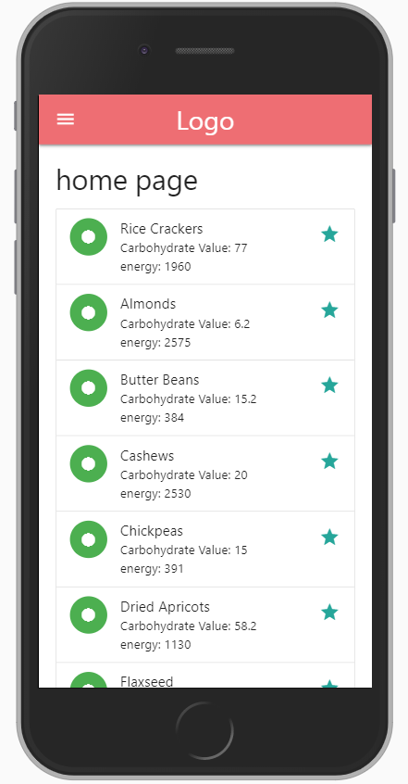

## Food item page

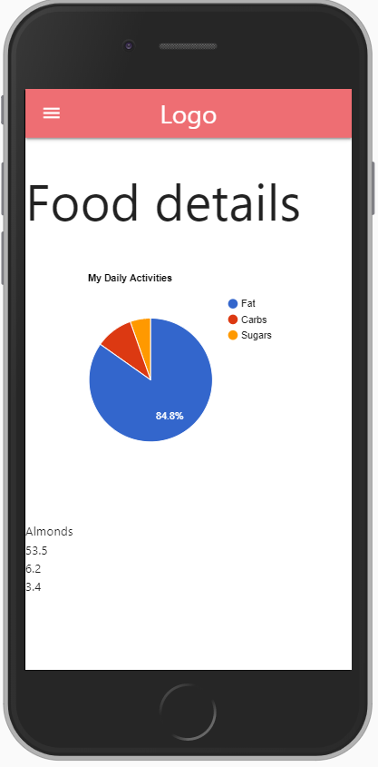

# JavaScript source code

## Package JSON

## app.js - your main server file

## Custom.js - script that dynamically generates list items

## readSession.js - script that reads sessionStorage data

## Script that displays data in a chart

# Command Line Screenshots

* 1. NPM Command for starting your node app

## Git Command

# URL to your remote repository

* 1. Screen shoot of GitHub repository
  2. URL to your GitHub repository